CHANGES HISTORY
PIC | Date | Remarks
BJM.MR | 2018.05.08 | Created
Ghaida | 2018.05.08

TOC
- Master Portfolio Bank Account
- Afa Bank Account Transaction
- Afa Bank Account Interest
- Afa Bank Account Balance
- Simpi Deposit
- Simpi Deposit Office

Diagram ENTITY RELATIONSHIP

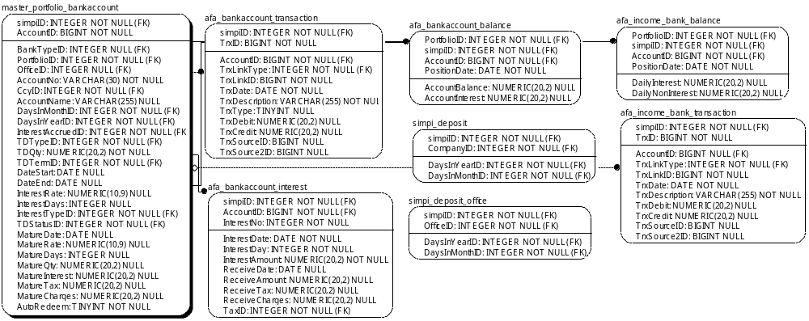

TABLE RELATIONSHIP
No | Table 1 | Table 2 | Type (1:1; 1:N; M:N) | Description
 | ats_ca_eq | ats_ca_eq_detail | M:N
 | ats_ca_fund | ats_ca_fund_detail | M:N

Name |  | ats_ca_eq
Objective
No | Column |  | Type | Rule  (PK, FK, Key, NN, Unik, Index) | Description
1. | CAID |  | Integer | NN
2. | SecuritiesID |  | BIGInteger | FK
3. | CAType |  | TINYInteger | NN
4. | DateAnnouncement |  | Date | Null
5. | DataRecording |  | Date | Null
6. | DateCumm |  | Date | Null
7. | DateDistribution |  | Date | Null
8. | DatePayment |  | Date | Null
9. | RatePrice |  | Numeric(20,9) | Null
10. | RateSource |  | Numeric(20,9) | Null
11. | RateTarget |  | Numeric(20,9) | Null

SAMPLE DATA
No | Column | Sample 1 | Sample 2 | Sample 3 | Sample 4
1. | CAID
2. | SecuritiesID
3. | CAType
4. | DateAnnouncement
5. | DataRecording
6. | DateCumm
7. | DateDistribution
8. | DatePayment
9. | RatePrice
10. | RateSource
11. | RateTarget

Name |  | ats_ca_eq_detail
Objective
No | Column |  | Type | Rule  (PK, FK, Key, NN, Unik, Index) | Description
1. | CAID |  | Integer | FK
2. | PortfolioID |  | Integer | FK
3. | Qty |  | Numeric(20,5) | Null
4. | ReceiveAmount |  | Numeric(20,2) | Null
5. | ReceiveShare |  | Numeric(20,9) | Null

SAMPLE DATA
No | Column | Sample 1 | Sample 2 | Sample 3 | Sample 4
1. | CAID
2. | PortfolioID
3. | Qty
4. | ReceiveAmount
5. | ReceiveShare

Name |  | ats_ca_fund
Objective
No | Column |  | Type | Rule  (PK, FK, Key, NN, Unik, Index) | Description
1. | CAID |  | Integer | Null
2. | SecuritiesID |  | BIGInteger | FK
3. | CAType |  | Integer | Null
4. | DateNav |  | Date | Null
5. | DateTransaction |  | Date | Null
6. | DatePayment |  | Date | Null
7. | CARate |  | Numeric(20,9) | Null

SAMPLE DATA
No | Column | Sample 1 | Sample 2 | Sample 3 | Sample 4
1. | CAID
2. | SecuritiesID
3. | CAType
4. | DateNav
5. | DateTransaction
6. | DatePayment
7. | CARate

Name |  | ats_ca_fund_detail
Objective
No | Column |  | Type | Rule  (PK, FK, Key, NN, Unik, Index) | Description
1. | CAID |  | Integer | FK
2. | PortfolioID |  | Integer | FK
3. | UnitBalance |  | Numeric(20,5) | Null
4. | ReceiveAmount |  | Numeric(20,2) | Null
5. | ReceiveUnit |  | Numeric(20,9) | Null

SAMPLE DATA
No | Column | Sample 1 | Sample 2 | Sample 3 | Sample 4
1. | CAID
2. | PortfolioID
3. | UnitBalance
4. | ReceiveAmount
5. | ReceiveUnit

